**Prelab 5**

**1) Draw the connection diagram to interconnect the components.**

A)

**2) List the application areas of servo motor.**

A) Applications:

* RC Car
* RC Plane
* Robot
* Quadcopter

**3) Differentiate between servo motor and a DC motor.**

|  | **SERVO MOTOR** | **DC MOTOR** |
| --- | --- | --- |
| Wire system | The Servo motor is three wire system known as power, ground and control. | DC motor is two wire system known as power and ground |
| Assembly | It has an assembly of four things DC motor, gearing set, control circuit and a position sensor. | DC motor is an individual machine with no assembly. |
| Rotation | Servo motor does not rotate freely and continuously like DC motor. Its rotation is limited to 180⁰ | Movement of DC motor is continuous |
| Examples | They are used in robotic arms, legs or rudder control. | DC motor is used in car wheels, fans etc. |

A)

**4) Classify different motors available?**

A) Basic motors have been classified into three distinct types: AC motor, DC motor, and specialized motors.

* **AC motors** include both the synchronous motor and the induction motor.
* **DC motor** types include compound wound, PMDC motors, Series, and Shunt motors. The DC shunt motors are used for lifts, lathe machines, weaving machines, and industrial tools.
* **Special purpose motors** like the linear induction motor or servo motor have different application than the AC motor or the DC motor.

**Experiment 5**

**Aim:** Program to Interface Servo motor toRaspberry PI

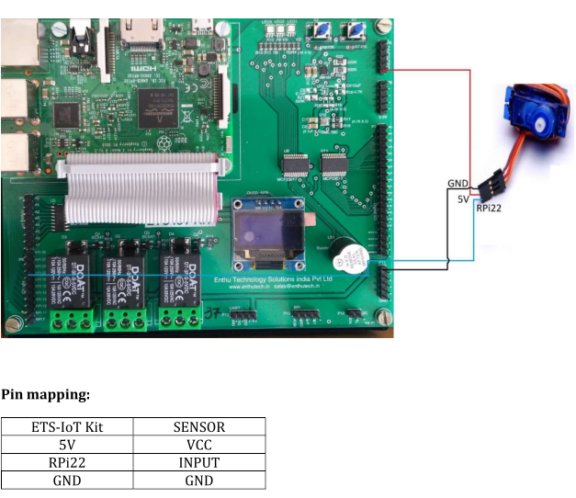

**SourceCode:**

import RPi.GPIO as GPIO

import time

GPIO.setmode(GPIO.BOARD)

GPIO.setup(12, GPIO.OUT)

p = GPIO.PWM(12, 50)

p.start(7.5)

try:

while True:

p.ChangeDutyCycle(2.5) # turn towards 0 degree

time.sleep(1) # sleep 1 second

p.ChangeDutyCycle(7.5) # turn towards 90 degree

time.sleep(1) # sleep 1 second

p.ChangeDutyCycle(12.5) # turn towards 180 degree

time.sleep(1) # sleep 1 second

except KeyboardInterrupt:

p.stop()

GPIO.cleanup()

**Output:**

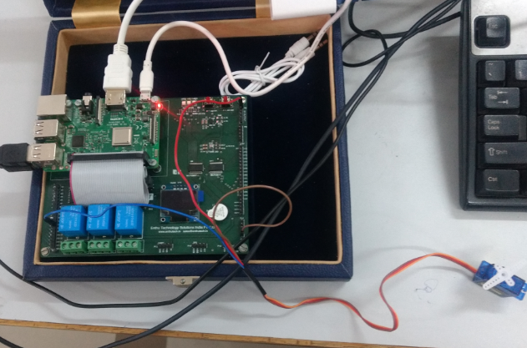

**Aim:** Program to Interface Stepper motor toRaspberry PI

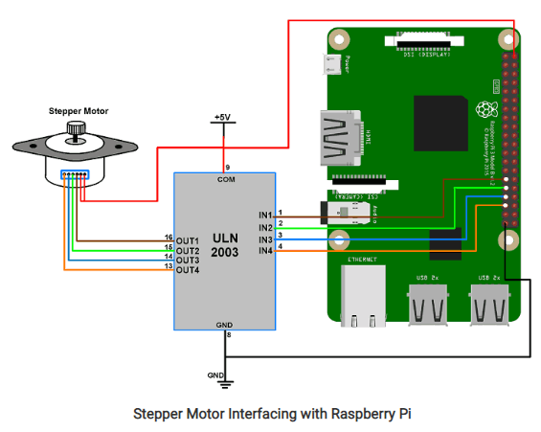

**SourceCode:**

import RPi.GPIO as GPIO

from time import sleep

import sys

#assign GPIO pins for motor

motor_channel = (29,31,33,35)

GPIO.setwarnings(False)

GPIO.setmode(GPIO.BOARD)

GPIO.setup(motor_channel, GPIO.OUT)

motor_direction = input('select motor direction a=anticlockwise, c=clockwise: ')

while True:

try:

if(motor_direction == 'c'):

print('motor running clockwise\n')

GPIO.output(motor_channel, (GPIO.HIGH,GPIO.LOW,GPIO.LOW,GPIO.HIGH))

sleep(0.02)

GPIO.output(motor_channel, (GPIO.HIGH,GPIO.HIGH,GPIO.LOW,GPIO.LOW))

sleep(0.02)

GPIO.output(motor_channel, (GPIO.LOW,GPIO.HIGH,GPIO.HIGH,GPIO.LOW))

sleep(0.02)

GPIO.output(motor_channel, (GPIO.LOW,GPIO.LOW,GPIO.HIGH,GPIO.HIGH))

sleep(0.02)

elif(motor_direction == 'a'):

print('motor running anti-clockwise\n')

GPIO.output(motor_channel, (GPIO.HIGH,GPIO.LOW,GPIO.LOW,GPIO.HIGH))

sleep(0.02)

GPIO.output(motor_channel, (GPIO.LOW,GPIO.LOW,GPIO.HIGH,GPIO.HIGH))

sleep(0.02)

GPIO.output(motor_channel, (GPIO.LOW,GPIO.HIGH,GPIO.HIGH,GPIO.LOW))

sleep(0.02)

GPIO.output(motor_channel, (GPIO.HIGH,GPIO.HIGH,GPIO.LOW,GPIO.LOW))

sleep(0.02)

#press ctrl+c for keyboard interrupt

except KeyboardInterrupt:

#query for setting motor direction or exit

motor_direction = input('select motor direction a=anticlockwise, c=clockwise or q=exit: ')

#check for exit

if(motor_direction == 'q'):

print('motor stopped')

sys.exit(0)

**Output:**

